<!DOCTYPE html>

<html lang="en">

<html>

<head>

<title>Tanish Chauhan's Webpage</title>

<link rel="stylesheet" href="mystyle4.css">

<style>

body {

background-image: url("tokyo-pink.jpg");

background-attachment: fixed;

background-size: cover;

}

</style>

</head>

<h1 id="heading">

Welcome to Tokyo!

</h1>

<div id="div1">

<p>

Spring (March-May)<br>

There may be days in March when you need a heavy jacket, but the cold eases considerably in April and by May it can be warm enough for short sleeves during the day. Peak cherry blossom season runs from late March through early April.<br>

Summer (June-August)<br>

The rainy season lasts from late June through around mid-July, with frequent rain and high humidity. After the rains, July and August usher in a steady stream of midsummer heat with temperatures over 30°C, including especially hot and humid days when the temperature rises above 35°C.<br>

Autumn (September-November)<br>

The temperature can rise over 30°C even in September, but both temperature and humidity begin to fall gradually. The peak season for viewing fall foliage starts in mid November. It is recommended to bring a heavy jacket when you come to Tokyo in November.<br>

Winter (December-February)<br>

Constant low temperatures make a jacket and coat indispensable, and it occasionally snows even in the city center.<br>

<hr>

Japan Meteorological Agency<br>

http://www.jma.go.jp/en/yoho/319.html<br>

</p>

</div>

<div id="div2">

<p>

Cashless payment<br>

In accordance with government policy, cashless transactions are promoted in large stores, restaurants, and shopping malls and can be used in many independent stores.<br>

</p>

</div>

<div id="div3">

<p>

Free Wi-Fi<br>

From cafés to train stations to airports, an increasing number of locations in Tokyo offer high-speed Internet connection via free Wi-Fi. Wi-Fi logos are displayed where services are available.<br>

Japan Connected: Free Wi-Fi<br>

Wi-Fi hotspot guide<br>

http://www.ntt-bp.net/jcfw/use/index.html<br>

TOKYO FREE Wi-Fi<br>

Free Wi-Fi Guide<br>

http://www.wifi-tokyo.jp/<br>

</p>

</div>

<div id="div4">

<p>

Electricity<br>

Voltage in Japan is 100 V, while frequency varies by location: 50 Hz in eastern Japan including Tokyo and 60Hz in western Japan. A 2-flat-pin type socket is used.<br>

</p>

</div>

<div id="div5">

<p>

Smoking<br>

In Tokyo, smoking is prohibited indoors at restaurants, drinking establishments, accommodations and other facilities used by many people, and only permitted in dedicated smoking rooms inside buildings (effective from April 2020). Smoking is also prohibited outdoors – on the streets and in parks in some areas of Tokyo. Please smoke in designated areas only.<br>

</p>

</div>

<div id="div6">

<p>

Language<br>

<hr>

Japanese is the official language of Japan and English is widely spoken in Tokyo. Information desks at various facilities are often staffed with people who can speak English.<br>

</p>

</div>

<div id="div7">

<p>

Visa<br>

<hr>

Japan has a visa waiver agreement with 68 countries and regions, under which delegates can enter the country for a short-term stay simply with their valid passport.<br>

*Due to the novel coronavirus (COVID-19), the Visa Exemption Arrangements with 68 countries and regions are subject to change.<br>

<hr>

For more information, please visit the website of the Ministry of Foreign Affairs of Japan:<br>

https://www.mofa.go.jp/j_info/visit/visa/short/novisa.html<br>

</p>

</div>

<div id="div8">

<p>

Transportation / Airport<br>

<hr>

A well-developed transportation network allows easy and convenient movement in and around the city, so you can come and go almost anywhere just by trains, subways or buses.<br>

</p>

</div>

<div id="div9">

<p>

Suica and Pasmo Cards<br>

Smart cards Suica and Pasmo can be used on almost all rail and bus lines in the Tokyo metropolitan area, and are also accepted by a growing number of taxis. Suica IC cards are available for purchase at JR stations. Welcome Suica cards which require no deposit and expire in 28 days are also available. Pasmo cards are available at subway, private railway stations or bus depots. You can also use these cards for shopping as electronic money at an increasing number of registered shops.<br>

<hr>

Suica<br>

https://www.jreast.co.jp/e/pass/suica.html<br>

<hr>

Pasmo<br>

https://www.pasmo.co.jp/visitors/en/normalpasmo/<br>

</p>

</div>

<div id="div10">

<p>

Taxis<br>

In addition to queuing for a taxi at a taxi stand, you can also flag down an unoccupied taxi on the street by raising your hand. The taxi's rear left-side door will open for you automatically, so there is no need to open it for yourself. Fares are paid at the conclusion of the ride, but some taxis cannot accept smart cards or credit cards, so be sure to check before you get in.<br>

<hr>

Taxi fares<br>

In the 23 wards of Tokyo, Musashino city and Mitaka city, the initial fare of 410 yen covers the first 1.052 kilometers, beyond which 80 yen is added for each additional 237 meters. Many taxis have adopted a fare system based on time and distance that also adds an 80 yen surcharge for each 90 seconds traveling at less than 10 kilometers per hour.<br>

Japan uses yen (Japanese: 円, symbol: ¥, code: JPY). Coins come in 1, 5, 10, 50, 100, and 500-yen denominations while bills come in 1,000; 2,000; 5,000; and 10,000-yen denominations. As of August 2021, the exchange rate is 110 yen to the US dollar and 130 yen to the Euro.<br>

</p>

</div>

<div id="div11">

<p>

Credit Cards<br>

<hr>

International credit cards such as American Express, Visa, Diners Club, and MasterCard can be used at most banks, hotels, inns, and stores. Although not accepted at as many locations as these cards, China UnionPay can also be used. However, some stores do not accept any credit cards, so it is a good idea to have some cash on hand.<br>

Cash advances (ATM)<br>

Roughly 32,000 Japan Post Bank ATMs located throughout Japan, as well as over 25,000 Seven Bank ATMs installed in 7-Eleven convenience stores, offer cash advances for credit cards issued overseas. Most 7-Eleven convenience stores are open 24/7. Logos displayed on or near the ATMs indicate which credit cards can be used.<br>

</p>

</div>

<div id="div12">

<p>

Tipping<br>

<hr>

It is not necessary to tip for service in Japan at places such as restaurants, bars, taxis, airports and hotels. However, hotels and some restaurants indicate an additional service charge on their bills or menus, respectively.<br>

</p>

</div>

</body>

</html>

**Spring (March-May)**

There may be days in March when you need a heavy jacket, but the cold eases considerably in April and by May it can be warm enough for short sleeves during the day. Peak cherry blossom season runs from late March through early April.

**Summer (June-August)**

The rainy season lasts from late June through around mid-July, with frequent rain and high humidity. After the rains, July and August usher in a steady stream of midsummer heat with temperatures over 30°C, including especially hot and humid days when the temperature rises above 35°C.

**Autumn (September-November)**

The temperature can rise over 30°C even in September, but both temperature and humidity begin to fall gradually. The peak season for viewing fall foliage starts in mid November. It is recommended to bring a heavy jacket when you come to Tokyo in November.

**Winter (December-February)**

Constant low temperatures make a jacket and coat indispensable, and it occasionally snows even in the city center.  
  
Japan Meteorological Agency  
<http://www.jma.go.jp/en/yoho/319.html>

**Money, tipping**

**Currency**

**Cashless payment**

In accordance with government policy, cashless transactions are promoted in large stores, restaurants, and shopping malls and can be used in many independent stores.

**Free Wi-Fi**

From cafés to train stations to airports, an increasing number of locations in Tokyo offer high-speed Internet connection via free Wi-Fi. Wi-Fi logos are displayed where services are available.

**Japan Connected: Free Wi-Fi**

Wi-Fi hotspot guide  
<http://www.ntt-bp.net/jcfw/use/index.html>

**TOKYO FREE Wi-Fi**

Free Wi-Fi Guide  
<http://www.wifi-tokyo.jp/>

**Electricity**

Voltage in Japan is 100 V, while frequency varies by location: 50 Hz in eastern Japan including Tokyo and 60Hz in western Japan. A 2-flat-pin type socket is used.

**Smoking**

In Tokyo, smoking is prohibited indoors at restaurants, drinking establishments, accommodations and other facilities used by many people, and only permitted in dedicated smoking rooms inside buildings (effective from April 2020). Smoking is also prohibited outdoors – on the streets and in parks in some areas of Tokyo. Please smoke in designated areas only.

**Language**

Japanese is the official language of Japan and English is widely spoken in Tokyo. Information desks at various facilities are often staffed with people who can speak English.

**Visa**

Japan has a visa waiver agreement with 68 countries and regions, under which delegates can enter the country for a short-term stay simply with their valid passport.  
*Due to the novel coronavirus (COVID-19), the Visa Exemption Arrangements with 68 countries and regions are subject to change.

For more information, please visit the website of the Ministry of Foreign Affairs of Japan:  
<https://www.mofa.go.jp/j_info/visit/visa/short/novisa.html>

### Transportation / Airport

A well-developed transportation network allows easy and convenient movement in and around the city, so you can come and go almost anywhere just by trains, subways or buses.

#### Suica and Pasmo cards

Smart cards Suica and Pasmo can be used on almost all rail and bus lines in the Tokyo metropolitan area, and are also accepted by a growing number of taxis. Suica IC cards are available for purchase at JR stations. Welcome Suica cards which require no deposit and expire in 28 days are also available. Pasmo cards are available at subway, private railway stations or bus depots. You can also use these cards for shopping as electronic money at an increasing number of registered shops.  
  
Suica  
<https://www.jreast.co.jp/e/pass/suica.html>  
  
Pasmo  
<https://www.pasmo.co.jp/visitors/en/normalpasmo/>

#### Taxis

In addition to queuing for a taxi at a taxi stand, you can also flag down an unoccupied taxi on the street by raising your hand. The taxi's rear left-side door will open for you automatically, so there is no need to open it for yourself. Fares are paid at the conclusion of the ride, but some taxis cannot accept smart cards or credit cards, so be sure to check before you get in.

#### Taxi fares

In the 23 wards of Tokyo, Musashino city and Mitaka city, the initial fare of 410 yen covers the first 1.052 kilometers, beyond which 80 yen is added for each additional 237 meters. Many taxis have adopted a fare system based on time and distance that also adds an 80 yen surcharge for each 90 seconds traveling at less than 10 kilometers per hour.

Japan uses yen (Japanese: 円, symbol: ¥, code: JPY). Coins come in 1, 5, 10, 50, 100, and 500-yen denominations while bills come in 1,000; 2,000; 5,000; and 10,000-yen denominations. As of August 2021, the exchange rate is 110 yen to the US dollar and 130 yen to the Euro.

**Credit cards**

International credit cards such as American Express, Visa, Diners Club, and MasterCard can be used at most banks, hotels, inns, and stores. Although not accepted at as many locations as these cards, China UnionPay can also be used. However, some stores do not accept any credit cards, so it is a good idea to have some cash on hand.

**Cash advances (ATM)**

Roughly 32,000 Japan Post Bank ATMs located throughout Japan, as well as over 25,000 Seven Bank ATMs installed in 7-Eleven convenience stores, offer cash advances for credit cards issued overseas. Most 7-Eleven convenience stores are open 24/7. Logos displayed on or near the ATMs indicate which credit cards can be used.

**Tipping**

It is not necessary to tip for service in Japan at places such as restaurants, bars, taxis, airports and hotels. However, hotels and some restaurants indicate an additional service charge on their bills or menus, respectively.

**Cashless payment**

In accordance with government policy, cashless transactions are promoted in large stores, restaurants, and shopping malls and can be used in many independent stores.

**Free Wi-Fi**

From cafés to train stations to airports, an increasing number of locations in Tokyo offer high-speed Internet connection via free Wi-Fi. Wi-Fi logos are displayed where services are available.

**Japan Connected: Free Wi-Fi**

Wi-Fi hotspot guide  
<http://www.ntt-bp.net/jcfw/use/index.html>

**TOKYO FREE Wi-Fi**

Free Wi-Fi Guide  
<http://www.wifi-tokyo.jp/>

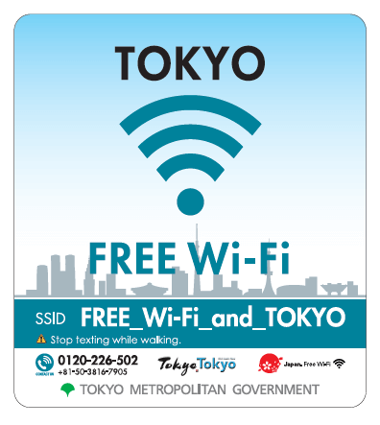

**Electricity**

Voltage in Japan is 100 V, while frequency varies by location: 50 Hz in eastern Japan including Tokyo and 60Hz in western Japan. A 2-flat-pin type socket is used.

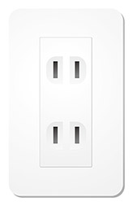

**Smoking**

In Tokyo, smoking is prohibited indoors at restaurants, drinking establishments, accommodations and other facilities used by many people, and only permitted in dedicated smoking rooms inside buildings (effective from April 2020). Smoking is also prohibited outdoors – on the streets and in parks in some areas of Tokyo. Please smoke in designated areas only.

**Language**

Japanese is the official language of Japan and English is widely spoken in Tokyo. Information desks at various facilities are often staffed with people who can speak English.

**Visa**

Japan has a visa waiver agreement with 68 countries and regions, under which delegates can enter the country for a short-term stay simply with their valid passport.  
*Due to the novel coronavirus (COVID-19), the Visa Exemption Arrangements with 68 countries and regions are subject to change.

For more information, please visit the website of the Ministry of Foreign Affairs of Japan:  
<https://www.mofa.go.jp/j_info/visit/visa/short/novisa.html>

### Transportation / Airport

A well-developed transportation network allows easy and convenient movement in and around the city, so you can come and go almost anywhere just by trains, subways or buses.

#### Average time to Key destinations from Airports

* 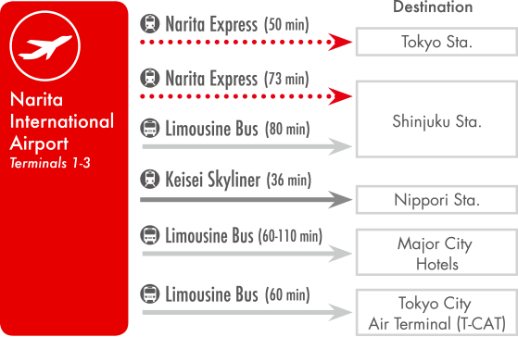
* 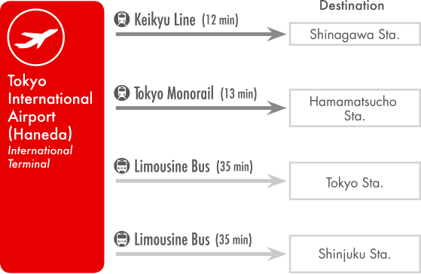

#### Getting around Tokyo

A network of train lines operated by JR East Japan and the subway lines of Tokyo Metro and Toei link stations around Tokyo. Symbols and signage at the stations are multilingual in English, Korean and Chinese. Train timetables are located on the platforms and are very reliable since trains in Tokyo run on time.

#### Suica and Pasmo cards

Smart cards Suica and Pasmo can be used on almost all rail and bus lines in the Tokyo metropolitan area, and are also accepted by a growing number of taxis. Suica IC cards are available for purchase at JR stations. Welcome Suica cards which require no deposit and expire in 28 days are also available. Pasmo cards are available at subway, private railway stations or bus depots. You can also use these cards for shopping as electronic money at an increasing number of registered shops.  
  
Suica  
<https://www.jreast.co.jp/e/pass/suica.html>  
  
Pasmo  
<https://www.pasmo.co.jp/visitors/en/normalpasmo/>

#### Taxis

In addition to queuing for a taxi at a taxi stand, you can also flag down an unoccupied taxi on the street by raising your hand. The taxi's rear left-side door will open for you automatically, so there is no need to open it for yourself. Fares are paid at the conclusion of the ride, but some taxis cannot accept smart cards or credit cards, so be sure to check before you get in.

#### Taxi fares

In the 23 wards of Tokyo, Musashino city and Mitaka city, the initial fare of 410 yen covers the first 1.052 kilometers, beyond which 80 yen is added for each additional 237 meters. Many taxis have adopted a fare system based on time and distance that also adds an 80 yen surcharge for each 90 seconds traveling at less than 10 kilometers per hour.